What is version control?

* A system that keeps records of your changes
* Allows for collaborative development
* Allows you to know who made what changes and when
* Allows you to revert any changes and go back to a previous state

What is GIT (Started in 2005)

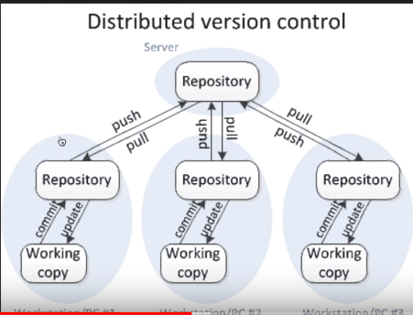

•  Distributed version control

•  Users keep entire code and history on their location machines

•  Users can make any changes without internet access   (Except pushing and pulling changes from a remote server)

Install Git: Windows - <http://git-scm.com/download/win>

After installing Git in your Windows system, just open your folder/directory where you want to store all your project files; right click and select ‘Git Bash here’.

What is GIT HUB?

* A website to upload your repositories online
* Provides backup
* Provides visual interface to your repo
* Makes collaboration easier

Work flow of Git:

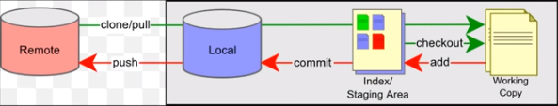

Key Concepts

Repositories (Often shortened to ‘repo’)

* A collection of all the ﬁles and the history of those ﬁles, consists of all your commits
* Can live on a local machine or on a remote server (GitHub!)
* The act of copying a repository from a remote server is called cloning
* Cloning from a remote server allows teams to work together, a folder is created after cloned in the local

git clone <repo url from github account>

* The process of downloading commits that don’t exist on your machine from a remote repository is called pulling changes

git pull --all

* The process of adding your local changes to the remote repository is called pushing changes

git push –u origin master

**Three main trees:**

There are a lot of ‘states’ and ‘places’ a ﬁle can be

**Working directory:** Local on your computer

**Staging/index:** When a ﬁle is ready to be put in a commit you add it onto the ‘index’ or ‘staging using $ git add filename.extension

**Commit history:** This commits your changes to the repository with an explanation message. Files are added to the local repo using $ git commit -m “message”

Every commit has hash code looks like “4aa7a6f26459b161b6ce96903a9bc066efae1dfc”

Key Concepts**: Branches**

* All commits in git live on some branch, there can be many branches
* The main branch in a project is called the master branch
* A bunch of commits linked together that live on some branch, contained in a repository
* When you want to make any changes to your project you make a new branch based on a commit

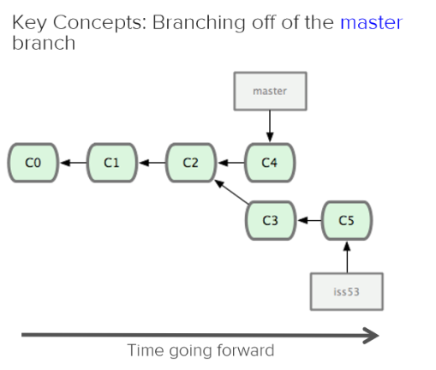

**Merging:** Once you’re done with your feature, you merge it back into master using

$ git merge branch-name

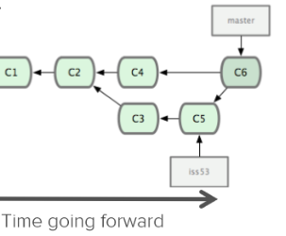

Other commands:

$ git branch: shows the current branch you are working with * mark

$ git checkout branch-name : switches to the branch you need

Get information about things:

log

status

diff

show

For marking objects, typically commits:

tag

Other commands:

checkout

revert

reset